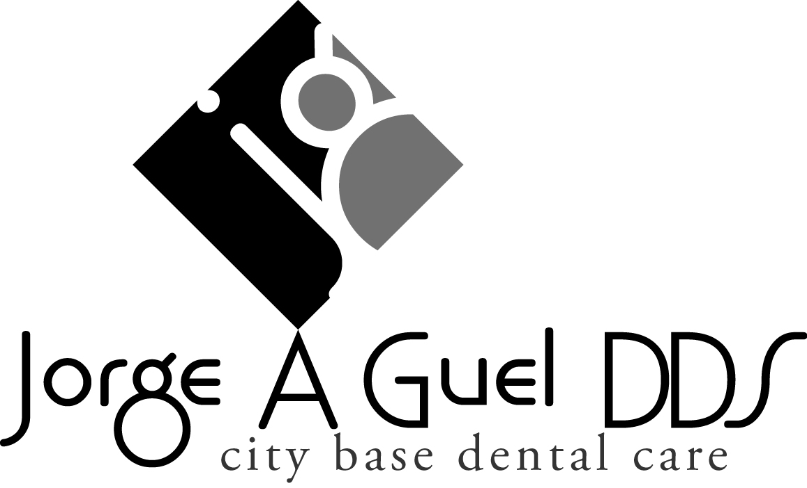

CONCERNING DENTAL INSURANCE
_____________________________
Name of Dental Insurance

As a courtesy, we will have a staff person to assist you in attempting to verify your dental insurance coverage. There is no guarantee of insurance coverage or payment. You should be aware that your dental insurance company does not guarantee payment, does not cover all procedures, and may not pay for any dental services provided.
WE WILL CHECK YOUR INSURANCE PRIOR TO COMING TO OUR OFFICE FOR THE FIRST TIME, AFTER THAT, ANY TIME YOUR INSURANCE CHANGES OR TERMINATES IT IS YOUR RESPONSIBILITY TO ADVISE US OF ANY CHANGES. WE WILL BE HAPPY TO VERIFY YOUR NEW BENEFITS AND UPDATE YOUR RECORDS.
I authorize and request my insurance company to pay directly to Dr. Jorge Guel, unless otherwise payable to me. I understand that there is no guarantee of insurance coverage or payment and that my dental insurance carrier may deny payment or pay less than the actual bill of services. I agree to be responsible for payment for all services rendered on my behalf or my dependents.
By signing below, you acknowledge that you have been fully informed in advance of receiving treatment that your insurance may deny payment for some or all of the dental services that may be recommended and provided by Dr. Jorge A Guel or the hygienists of City Base Dental Care. You agree to be responsible for payment in full for charges, including “Covered Services” denied coverage by your insurance.

___________________________________________ ________________
Signature of Patient or Guardian Date

